4.4.2.2 Maths for Regular Expressions

Specification Requirements
Students should:
Be familiar with the concept of a set and the following notations for specifying a set:
A = {1, 2, 3, 4, 5 } or set comprehension:
A = {x | x∈ N ∧ x ≥ 1 } where A is the set consisting of those objects x such that x ∈ N and x ≥ 1 is true.

Know that the empty set, {}, is the set with no elements.

Know that an alternative symbol for the empty set is Ø.

Be familiar with the compact representation of a set, for example, the set {0n1n | n ≥ 1}.This set contains all strings with an equal number of 0 s and 1s

Be familiar with the concept of:
- finite sets
- infinite sets
- countably infinite sets
- cardinality of a finite set
- Cartesian product of sets.

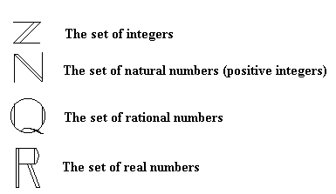
 Empty set

Define the Keywords

Set

Set Values

Set Comprehension

Finite set

Infinite set

Cardinality

Cartesian Product

Activity
Create a new Java project Sets and a class SubSet that extends the https://docs.oracle.com/javase/8/docs/api/java/util/HashSet.html HashSet class and implements the following methods.

Set Union(Set)
E.g. A = (0, 1, 3, 5 ,7 ,9), B = {0, 2, 4, 6, 8), result = {0, 1, 2, 3, 4, 5, 6 ,7 8 , 9}

Set Intersection(Set)
E.g. A = ( 1, 3, 5 ,7 ,9), B = {1, 3, 4, 6 , 8}, result = {1, 3}

Set Difference(Set)
E.g. A = (1, 2, 3, 4, 5, 6, 7, 8), B = {2, 4, 6, 8, 10), result = {1, 3, 5, 7, 10}

Boolean IsSubset(Set)
E.g. A = (1, 3, 5 ,7 ,9, ..), B = {1, 2, 3, 4, 5, ..}, result = true

Boolean IsEmpty(Set)
E.g. A = (0, 1, 3, 5 ,7 ,9}, result = false

Integer Cardinality(Set)
E.g. A = (0, 1, 3, 5 ,7 ,9), result = 6

